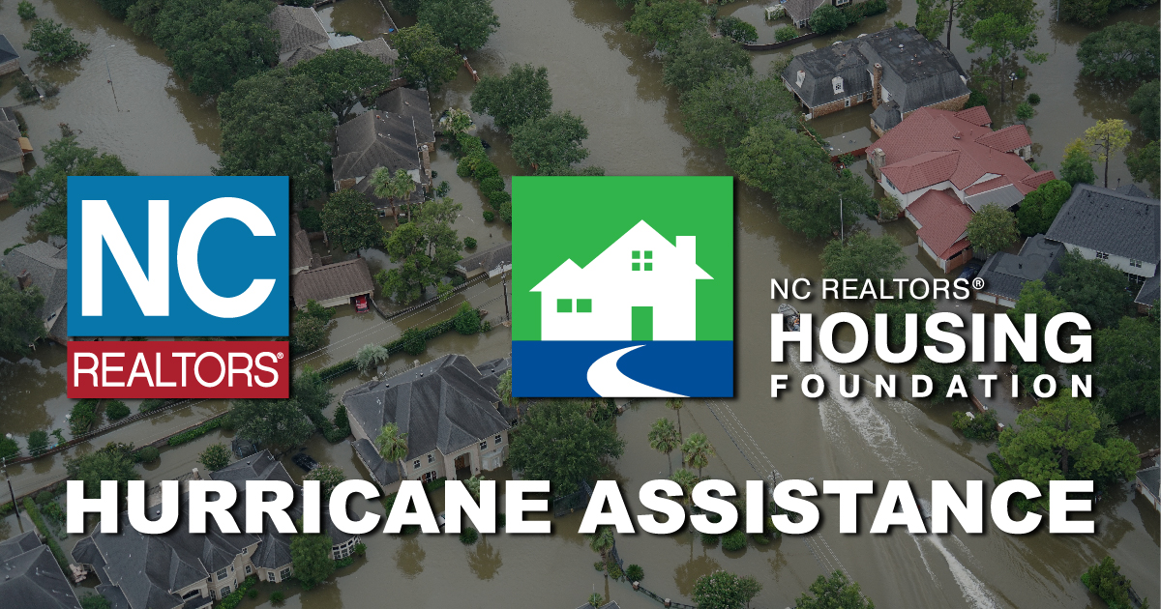

PURPOSE
To help applicants fill out applications for housing (mortgage or rent) assistance for homes impacted by Hurricane Florence.

WHAT TO BRING
- Copy of mortgage statement or lease agreement
- Proof of residence (NC Drivers License, electricity bill, etc.)
- Photos of damage to home

DATES

LOCATION

CONTACT
Please contact

